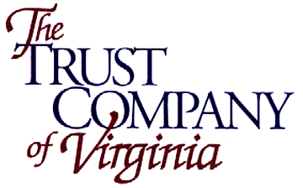

Board of Director’s & Audit Committee Meetings
Wednesday, February 5, 2014

2:30 p.m. Audit Committee Meeting
- Review November 13, 2013 Audit Comm. Minutes
- Internal 4th Quarter Report – Dave Robinson

3:00 p.m. Board of Directors Meeting – TCVA

    - Review November 13, 2013 Minutes
    - Audit Committee Report
    - TAIC Minutes – Donna Chapman
    - TIC Minutes & Performance Report – Beth Swartz
    - Review Regulatory Reports (Corporate Asset Purchases; QTL)
    - Review Financials through December 31, 2013
    - Approve 2014 Budget
    - Approve Amended and Restated ESOP Plan

4:00 p.m. TCV Financial Corp. Board of Directors Meeting

    - Review November 13, 2013 Minutes
    - Review Corporate Resolutions
    - New Board Member Recommendation

The next meeting is Tuesday, April 8, 2014 beginning with the Audit Committee at 9:00 a.m. Note: This is also the Annual Shareholder Meeting, beginning at 10:00 a.m. followed by the Annual Organizational Meeting.

Please call Liz at (804) 272-9044 to confirm your attendance. If you will not be attending in person, please provide an alternate contact number.

